**Custom Partition Assignment:**

**Input:** Input_Partitioner.log

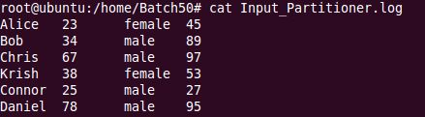

**Code:** customPartition.java

**Package:** com.mapred.cusompart

**Exported Jar file:** CustomPart.jar

**Commands:**  cp /home/mrinmoy/Downloads/MapReduce/Input_Partitioner.log .

cp /home/mrinmoy/Downloads/MapReduce/CustomPart.jar .

hadoop fs –mkdir /Part50

hadoop fs –put Input_Partitioner.log /Part50

hadoop jar CustomPart.jar com/mapred/custompart/customPartition /Part50/Input_Partitioner.log /PartOuts50

hadoop fs -cat /PartOuts50/part-r-00000

hadoop fs -cat /PartOuts50/part-r-00001

hadoop fs -cat /PartOuts50/part-r-00002

**Output:**

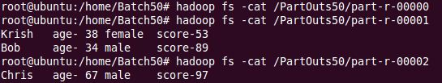

**Input:** Input_Partitioner.log



**Code:** customPartition.java

**Package:** com.mapred.cusompart

**Exported Jar file:** CustomParts.jar

**Commands:**  cp /home/mrinmoy/Downloads/MapReduce/Input_Partitioner.log .

cp /home/mrinmoy/Downloads/MapReduce/CustomParts.jar .

hadoop fs –mkdir /Part50

hadoop fs –put Input_Partitioner.log /Part50

hadoop jar CustomPart.jar com/mapred/custompart/customPartition /Part50/Input_Partitioner.log /PartsOut50

hadoop fs -cat /PartsOut50/part-r-00000

hadoop fs -cat /PartsOut50/part-r-00001

hadoop fs -cat /PartsOut50/part-r-00002

**Output:**

